

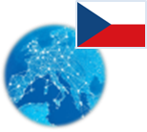 **Czech Republic** *Energy Union factsheet[1]*

1. **Macro-economic implications of energy activities**

Energy and transport are key sectors for the overall functioning of the economy as they provide an important input and service to the other sectors of the economy. Together the activity in these two sectors[2] accounted for 8.7 % of the total value added of the Czech Republic in 2015. Similarly, their share in total employment[3] was 6.8 % of total employment in 2015, of which 6.1 % in the transport sector and 0.7 % in the energy sector.

The decarbonisation of the energy and transport sectors will require significant investments and economic activity beyond the remit of these sectors themselves. The energy transition implies a structural shift in economic activity. Energy-related investment and jobs will in part migrate from traditional fossil fuel based activities towards construction, equipment manufacturing and other services related to the deployment of low carbon and clean energy technologies. At the moment the efforts related to the energy transition in other sectors cannot be reliably quantified and are therefore not included.

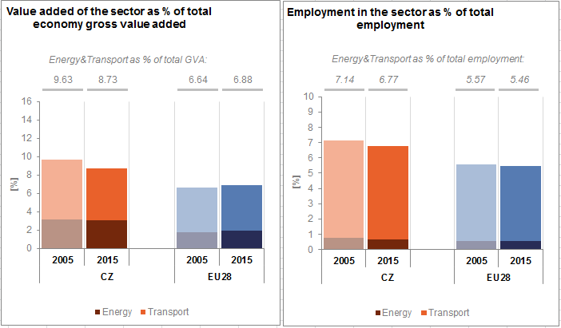

*(Source: Eurostat)*

In the case of renewable energy sector, both the direct as well as the indirect effects on employment are being estimated. According to EurObserv'ER, in 2015, the share of renewable energy related employment in total employment of the economy in the Czech Republic was at about 0.33 %, below the EU average of 0.54 %. The turnover of the renewable energy industry in the same year was estimated at around EUR 1 595 million, the biggest part being attributed to the biomass (EUR 860 million) followed by biofuels (EUR 330 million), and biogas (EUR 150 million) industries.

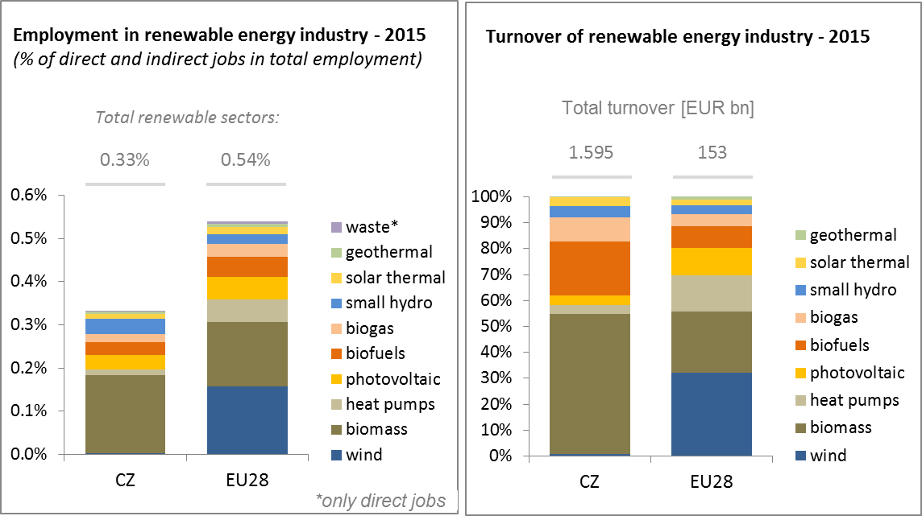

*(Source: EC based on Eurobserv'Er and Eurostat)*

An indication of the level of efforts and challenges encountered by the Czech Republic in the energy sector is given by the gross fixed capital formation (GFCF)[4]. Investments in the electricity and gas sectors, which are taken as reference sectors, peaked in 2010 at 2.3 % and have been decreasing since to 1.5 % in 2015.

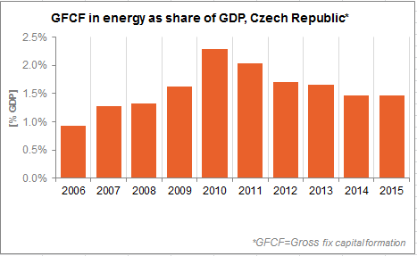

*(Source: Eurostat)*

In terms of trade, the Czech Republic is a net importer of oil and gas and a net exporter of electricity and coal. The trade deficit in oil has fallen from 3 % of GDP in 2006 to 2% in 2015 influenced by improvements in energy efficiency and a decrease in the prices of energy commodities, whereas the deficit in gas increased from 0.2 % to 0.6 % of GDP. At the same time the trade surplus in electricity and coal has declined from 0.8 to 0.2 % of GDP.

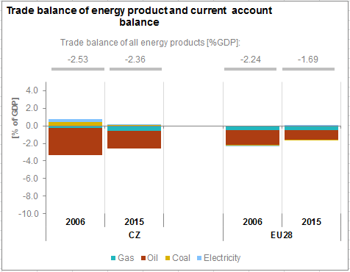

*(Source: Eurostat)*

1. **Energy security, solidarity and trust**
   1. **Energy Mix**

In comparison to the average energy mix in the EU, the Czech Republic's energy mix of primary energy products had in 2015 a lower share of renewable energy (9.8 % vs 13 %) and a higher share of nuclear energy (16 % vs 13.6 %). Conversely, natural gas had lower importance in the energy mix of the Czech Republic than the EU average (14.9% vs 22.0%). The same applies to oil (20.6 % vs 34.4 %). The Czech Republic uses more than the double of solid fuels than the EU average (38.1% vs 16.2%).

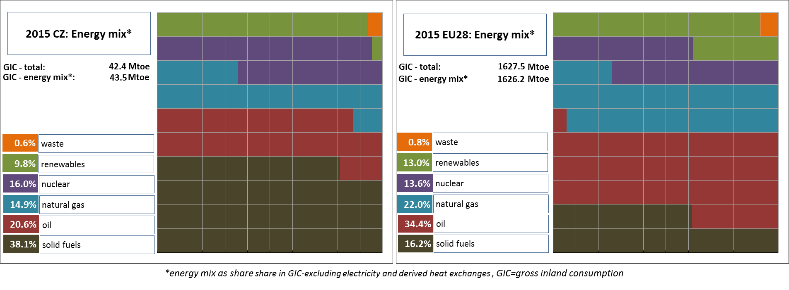

*(Source: Eurostat)*

* 1. **Import dependency and security of supply**

31.9 % of the Czech Republic's energy consumption came from imports in 2015, less than the EU average. This is due to the high importance of domestic coal and lignite as well as of nuclear energy in the energy mix, which assure together about 60 % of the country's energy needs.

The overall import dependency of the Czech Republic recorded an increase of about 4.1 % between 2005 and 2015, which is more than the import dependency increase (1.9 %) at the EU level over the same period. Still, the Czech Republic imported virtually all its natural gas and oil needs in 2015.

Russia supplied nearly two thirds of natural gas and 56.4 % of the crude oil in the Czech Republic, therefore it could be considered as dominant supplier. In 2015 Russian supplies were complemented by Norwegian gas supplies (34.5 %) - that wasn't the case during the previous years - and Azerbaijan and Kazakhstan oil supplies (together 43.2 %). The Czech gas network is very resilient and is able to support further source diversification. Its relatively high commercial gas storage capacity of 3.6 bcm further improves the country's security of gas supply.

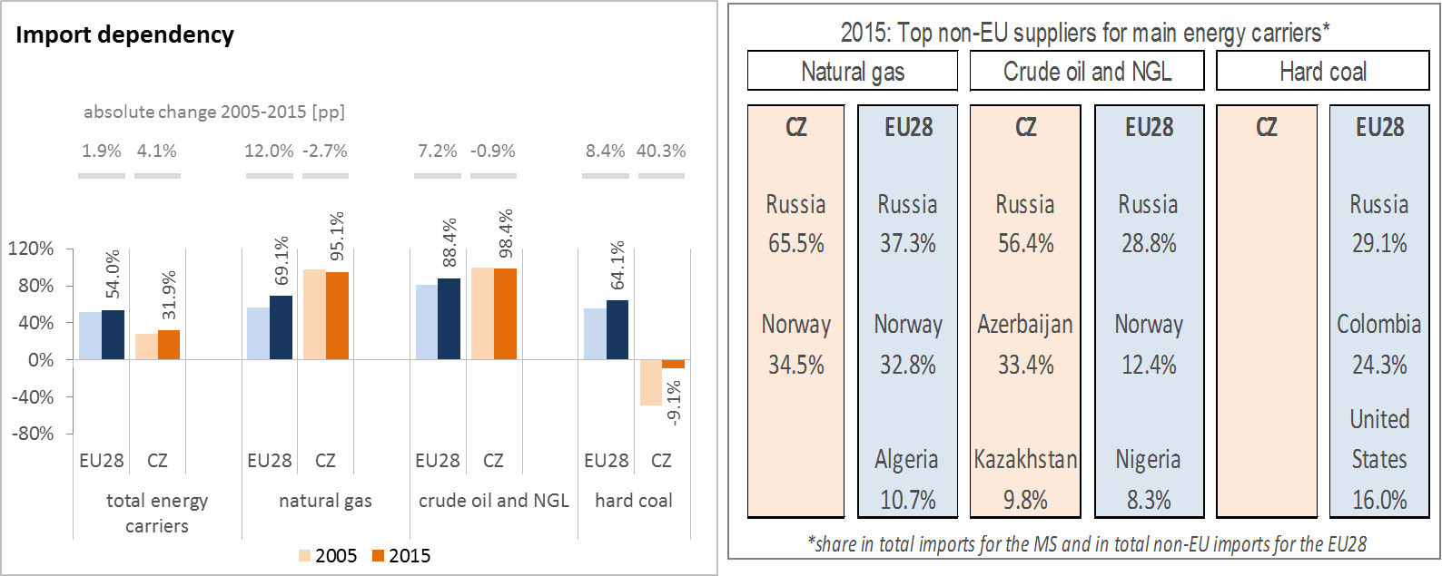

*(source: Eurostat)*

The two nuclear power plants (JE Temelín, JE Dukovany) in the Czech Republic are currently using fuel of Russian origin. In the past, it has been possible to procure such fuel from a decommissioned nuclear plant in Europe and one of the Czech nuclear plants has invested into the capacity to use fuel of US origins. The American fuel was used in JE Temelín from 2000 to 2010.

The security of gas supply regulation requires that, if the single largest gas infrastructure fails in one Member State, the capacity of the remaining infrastructure is able to satisfy the total gas demand during a day of exceptionally high gas demand. The Czech Republic complies with this rule, principally relying on its good interconnections with neighbouring countries.

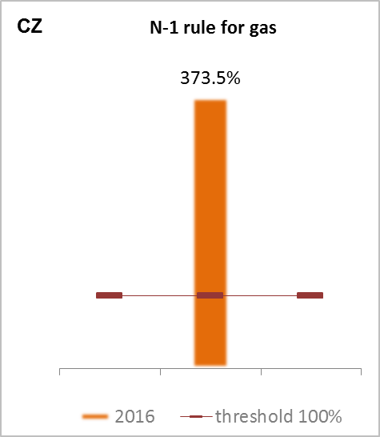

*(source: gas coordination group)*

1. **Internal market**
   1. **Interconnections and wholesale market functioning**
      1. **Electricity**

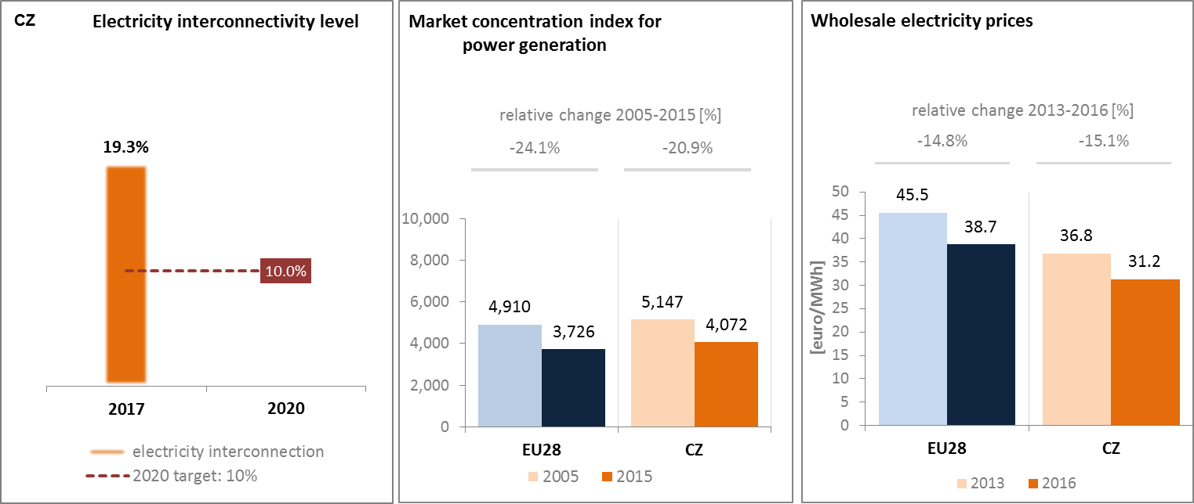

*(source: EC services based on ENTSOE source: EC services based on Eurostat source: EC services based on Platts and European power exchanges)*

The Czech Republic is part of the electricity system of Central Eastern Europe, and its wholesale electricity market is coupled with Slovakia, Hungary and Romania since 2014. The Czech electricity system is directly connected to all of the country's neighbours. In 2017 the electricity interconnection level[5] of the Czech Republic was 19.3 %, having increased from 17 % in 2014 and being well above the 2020 and 2030 EU targets of 10 % and 15 % respectively. The Czech Republic is exposed to loop flows from Germany, which cause its transmission system operator to bear significant costs of re-dispatching. Consequently the Czech Republic has put into operation phase-shifting transformer at its interconnectors with Germany. Congestion management remains an issue particularly for seven Member States (Austria, Czech Republic, Denmark, Germany, Hungary, Poland and Slovakia). This needs a solution that will facilitate cross-border electricity flows in Central Europe and across the Union while ensuring system security.

Concentration of the power generation market is slightly above EU average. Wholesale electricity prices are below the EU average (31.2 vs 38.7 EUR/MWh), and between 2013 and 2016 they recorded a slightly bigger decrease than the EU average (almost 15.1 % vs 14.8 %).

**Cluster of electricity transmission internal lines PCIs in the Czech Republic**

The “Czech North South Corridor” consists of PCI projects which will be implemented gradually until 2028. This reinforcement strategy enables the power flow from the North-Western border to the South-Eastern border of the Czech Republic. The implementation of this cluster is required in order to facilitate power flows in the direction North-South and East-West, to enhance the grid transfer capability between the Czech Republic and Germany and to connect the future thermal and RES generation facilities (including the connection point of wind generation at the substation Vernéřov). In addition, these projects ensure enhanced security of supply of the North-western part of Czech Republic in general terms.

* + 1. **Gas**

Wholesale gas prices in the Czech Republic remained at a slightly higher level than average EU gas prices over the last few years; however, they have been strongly correlated with German prices due to significant interconnectivity with Western European markets. Between 2011 and 2015, the market concentration index for wholesale gas supply significantly dropped due to a progressive diversification of supplies, moving away from the historical incumbent and owing to the establishment of physical reverse flow on all interconnection points. This was also made possible by the implementation of reverse flow capability on the network.

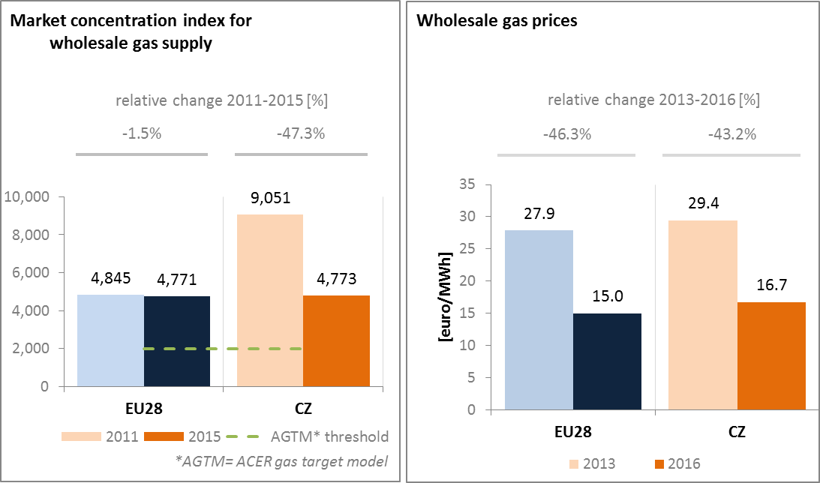

*(source: ACER for the left graph and EC services based on Platts, gas hubs, Eurostat for the right graph)*

The Czech Republic transits significant amounts of gas from Slovakia and also from Nord Stream back towards Germany (Waidhaus). Regional cooperation on the North-South gas corridor concept connecting Poland, Czech Republic, Slovakia, Hungary and Croatia has been a priority, though its implementation seems to have lost momentum. There are also intentions to create a closer regional cooperation to potentially create a common trading zone between the Czech Republic and Austria, with the potential inclusion of Slovakia.

* 1. **Retail electricity and gas markets**
     1. **Electricity**

In 2015 retail electricity prices for household customers in the Czech Republic were significantly below the EU average. Between 2013 and 2016, average band retail electricity prices for households decreased, but to a lesser extent than the wholesale prices. This may be partially explained by a slight increase in taxes and levies. The share of taxes and levies in retail electricity prices for households in the Czech Republic was much lower than the EU average between 2013 and 2016. The switching rates by consumers from one electricity supplier to another significantly dropped below the EU average between 2011 and 2015. There were several pilot projects of deployment of smart meters in the Czech Republic; however on the basis of cost-benefit analysis no broad deployment was yet accepted.

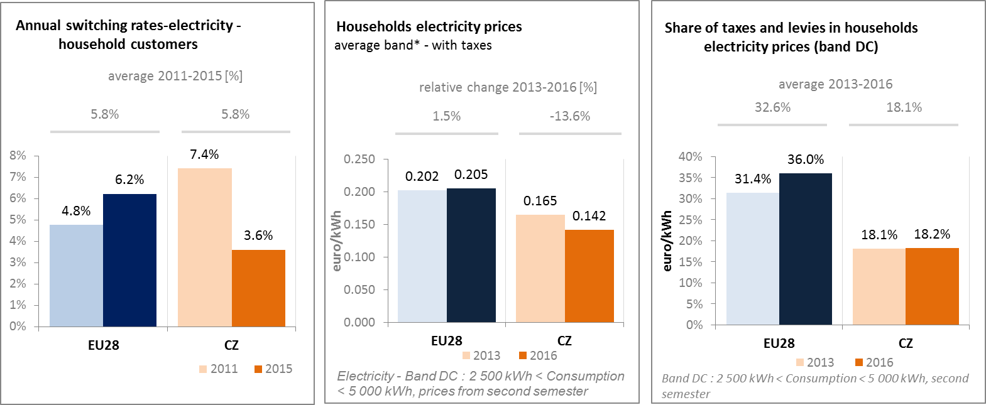

*(source: ACER) (source: Eurostat) (source: Eurostat)*

* + 1. **Gas**

In 2016 retail gas prices for households in the Czech Republic were slightly below the EU average. There were no significant changes in average retail gas prices for households and the wholesale prices either between 2013 and 2016. The share of taxes and levies in retail gas prices for households was slightly lower in the Czech Republic than the EU average. The switching rates by consumers from one gas supplier to another significantly dropped below the EU average over the same period.

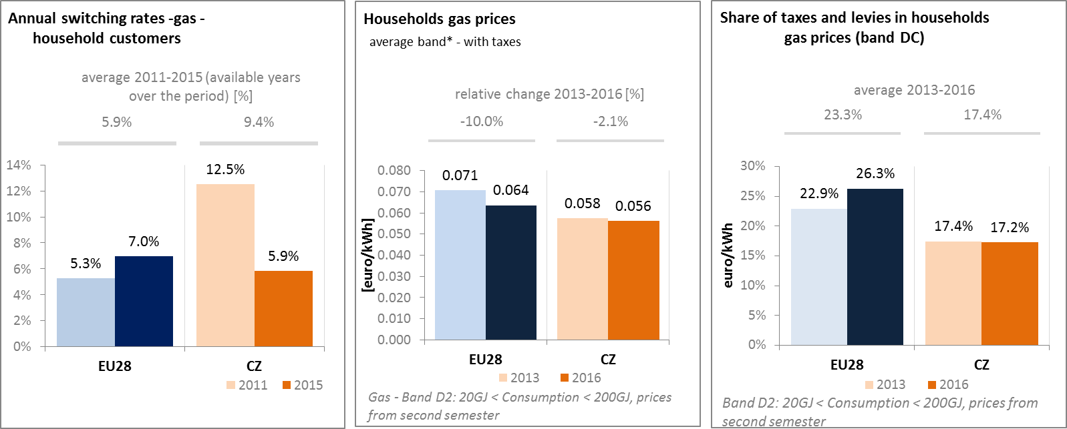

*(source: ACER) (source: Eurostat) (source: Eurostat)*

* + 1. **Market performance indicators**

According to DG JUST, the satisfaction of the Czech consumers with the services received on energy retail markets remains stable and comparable to the average EU satisfaction level.

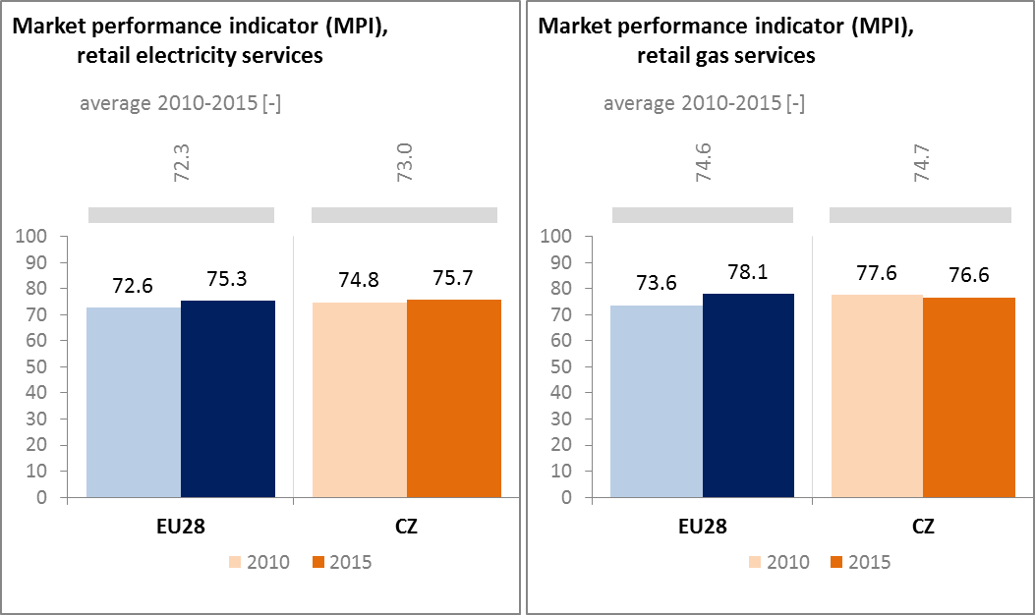

*Source: DG JUST survey)*

* 1. **Energy affordability**

In the Czech Republic the share of energy in total household expenditures of the lowest quintile of population is significantly higher than in the EU. This can be explained by lower purchasing power and a significant potential to improve energy performance of the residential building sector. However, in 2015 only a limited part (up to 13.5 %) of citizens below the at-risk-of poverty threshold considered that they were unable to keep their home adequately warm, even showing a decrease since 2005.

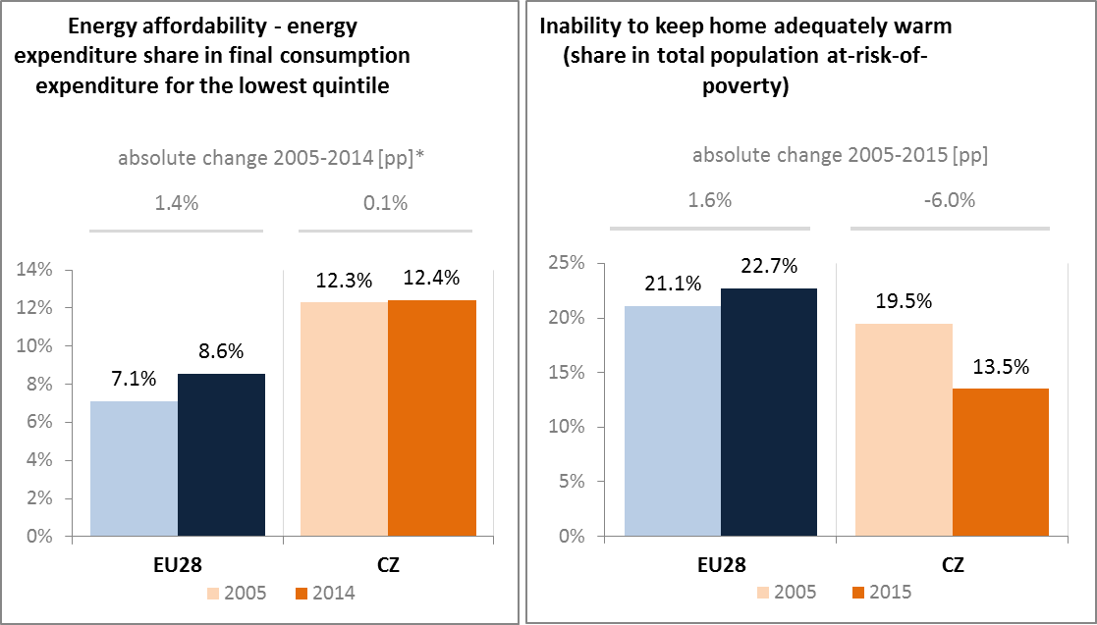

*(Source: ad-hoc data collection of DG ENER based on HBS with the support of Eurostat and national statistics)*

1. **Energy efficiency and moderation of demand**

After a decrease in 2014, both primary and final energy consumption have risen again in 2015. The inter-annual increase in final energy consumption was caused by significant fluctuations in temperature on annual basis. Final energy consumption in 2015 was influenced by high values of heating degree days in the heating season compared to 2013 and 2014. The value of final energy consumption in 2015 is in line with the trend of the long-term decline in energy consumption. Primary energy consumption in the Czech Republic reached 39.9 Mtoe and final energy consumption 24.2 Mtoe in 2015. Since 2005, even though the economic growth was greater than the EU average, the Czech Republic decreased its primary energy consumption by 6 % by 2015. Over the same period, final energy consumption also decreased by 8.1 %.

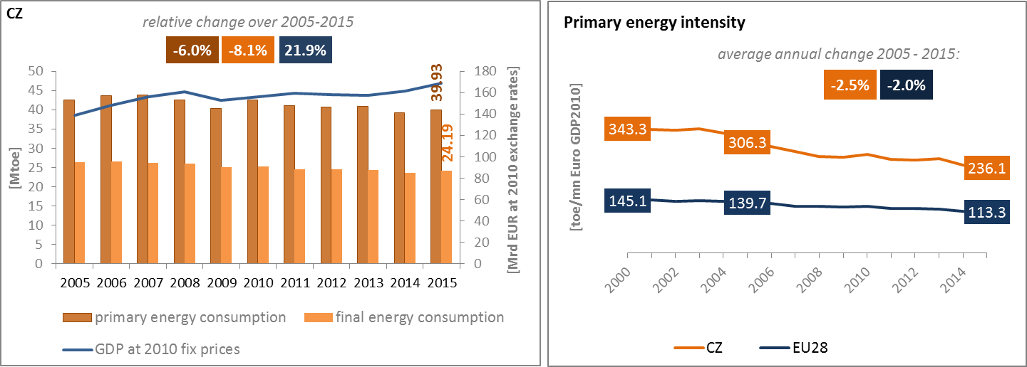

*(Source: Eurostat)*

Although primary energy intensity decreased over the 2005-2015 period faster that in the EU, it still remains one of the highest in the EU, more than the double of the EU average. In 2015 industry was the largest energy consuming sector in the Czech Republic, representing a share of 31.2 % in the total final energy consumption, which was well above the EU average (i.e. 25.3 %). Similarly, the energy consumption of the residential sector in the Czech Republic was slightly above the EU average, with a share in total final energy consumption of 27.2 %. As a consequence of the high energy consumption in the industrial and residential sectors, the share of energy consumption in transport and services is lower than the EU average.

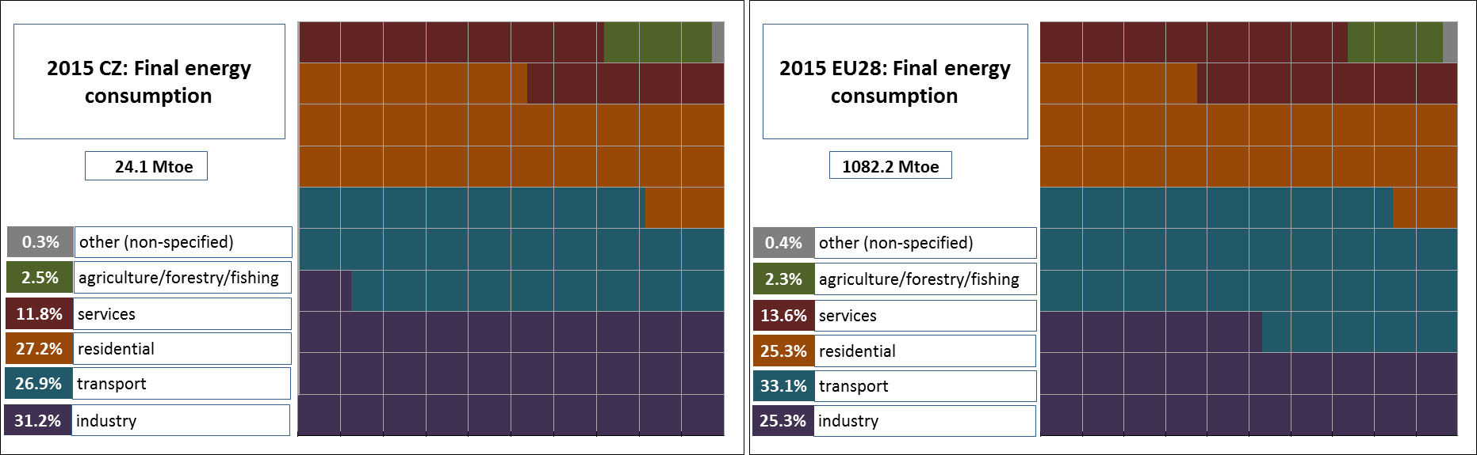

*(Source: Eurostat)*

Energy intensity in services sector and in particular in the industry in the Czech Republic managed to measurably decrease and got closer to the EU average between 2005 and 2015. However, in the residential sector, the progress towards better energy performance of buildings is slower than in the rest of the EU, despite significant allocations to this sector from the EU structural funds and from the national budget. Furthermore, the national energy efficiency actions and programs need to be properly implemented in order to meet the cumulative saving requirements stemming from Article 7 of the Energy Efficiency Directive.

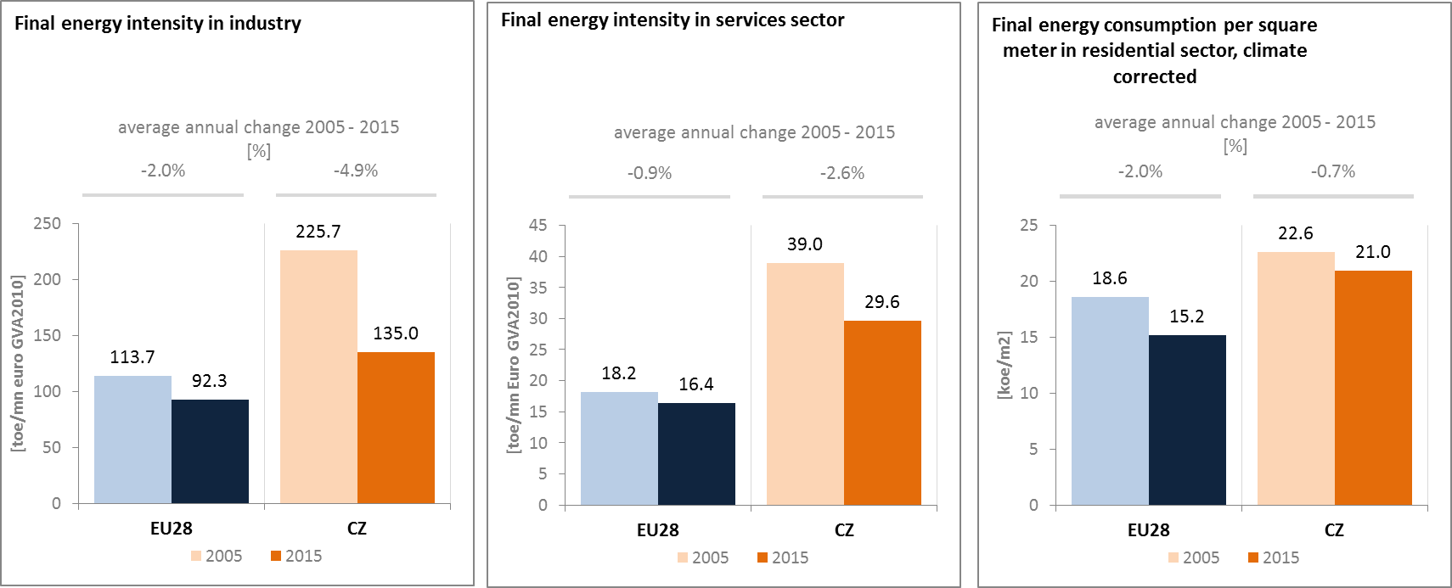

*(source: Eurostat) (source: Eurostat) (source: Odyssee database)*

Between 2005 and 2015 final energy consumption in the transport sector varied significantly from one year to another in the Czech Republic. It recorded an average annual increase of 0.7 % over this period, which was slower than the 2.1 % average annual increase of the GDP.

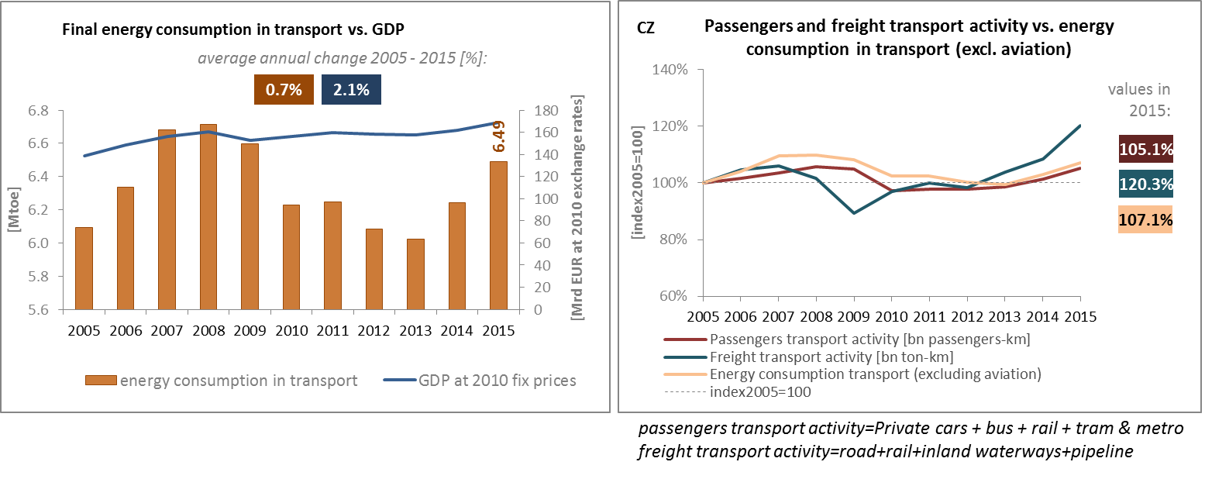

*(source: Eurostat) (source: Eurostat and DG MOVE pocketbook)*

The share of collective passengers' land transport in total passengers' transport increased from 24.5% to 25.9 % between 2005 and 2015, being higher than the EU average of 17.3 %.

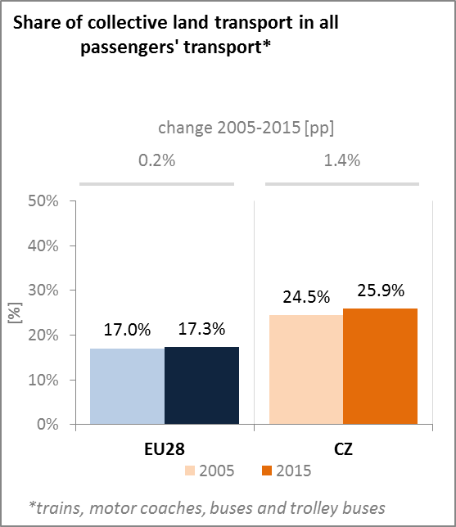

*(source: Eurostat)*

In order to further elaborate solutions and methods for funding individual transport areas, the Government adopted in January 2017 a Concept paper for freight transport 2017-2023 with a view to 2030. It sets the government's priorities for logistic and freight transport in the context of the long-term strategy for transport policy in the Czech Republic. Among others, it sets as a priority use of alternative energy in transport (CNG, LNG, hydrogen and electricity).

1. **Decarbonisation of economy**
   1. **GHG emissions**

In March 2017, the Czech Republic adopted its strategy for mitigation of climate change. The strategy defines a GHG emission reduction target for the year 2030 (-30 % compared to 2005) as well as an indicative emission level of 39 MtCO2eq for 2050 which corresponds to an indicative target of -80 % compared to 1990. The strategy also lists sectoral measures which could ensure the transition to low-carbon economy, such as electro-mobility and increased share of renewables, energy efficiency in buildings, recycling, more ecological agriculture and afforestation.

The Czech Republic continues to over-achieve its emission reduction targets – with total GHG emission reductions of 36 % in 1990-2016. In sectors not covered by the EU ETS, the Czech Republic overachieved its 2016 target by 10 percentage points, and is projected to further overachieve its 2020 target by 9 percentage points.

Despite the general reduction trend, GHG emissions continue to rise sharply in the following two sectors of the economy: landfilling and refrigeration / air conditioning. Waste emissions continue to grow, in particular emissions (mainly methane) from the treatment and disposal of municipal, industrial and other solid waste have increased by 68 % since 1990. Emissions of F-gases have increased over the last 10 years from 0.9 to 3.5 MtCO2eq, mainly due to use of HFCs in refrigeration and air conditioning.

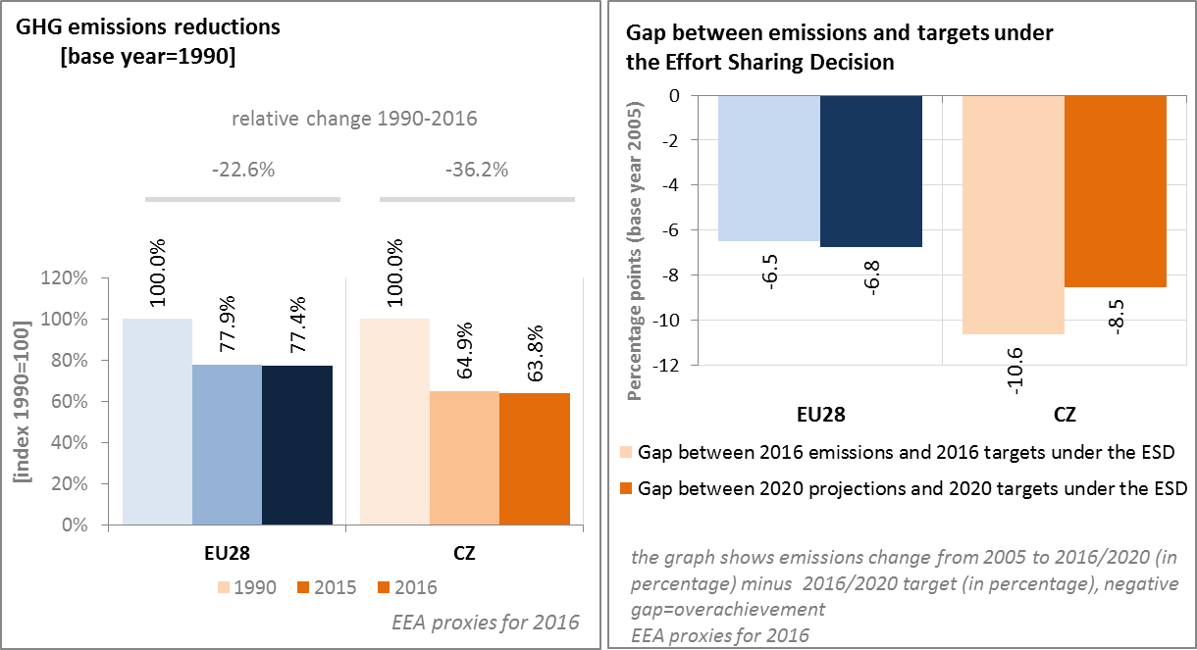

*(Source: EC and EEA)*

Despite certain investments in energy efficiency, the Czech Republic remains one of the most energy intensive and carbon intensive economies in the European Union – mainly due to a high share of industry in GDP, and a majority share of coal in electricity generation.

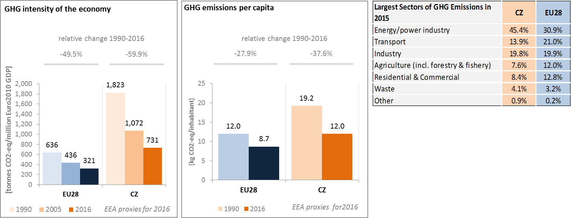

*(Source: EC and EEA)*

Preliminary accounts under the Kyoto Protocol for Czech Republic show overall removals of -1.6 Mt CO2-eq. as an annual average in the period 2013-2015. For comparison, the annual average of the EU-28 accounted for removals of -119.0 Mt CO2-eq. It should be noted that in this preliminary simulated accounting exercise, removals from Forest Management did by far not exceed the accounting cap.

Removals by Afforestation are clearly higher than emissions by Deforestation. In 2013 and 2014, their relative importance was small as compared to the removals by Forest Management; however, the notable reduction of removals by Forest Management in 2015 put removals by Afforestation in first place. Overall, the graph suggests a clear reduction in removals, in particular for 2015 as compared to previous years due to declining removals by Forest Management. Afforestation shows an increase in removals while emissions by Deforestation decrease over the course of the three-year period.

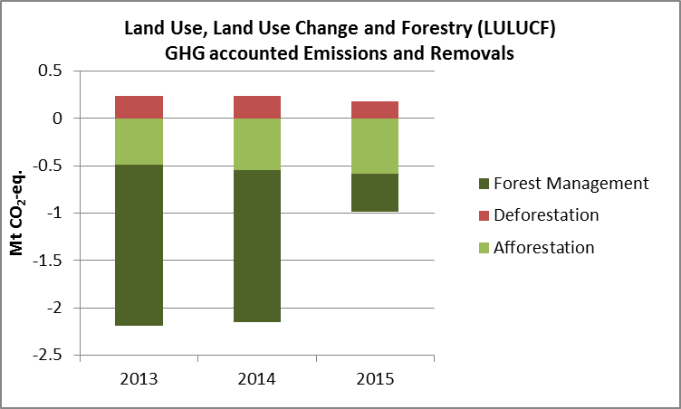

*Note: Forest Management credits are capped and presented as yearly averages when the total Forest Management credits of the considered period exceed the simulated cap over the same period.*

*(source: EC and EEA)*

**CO2 emissions in transport and alternative fuelled vehicles**

In Czech Republic, the CO2 emissions from road transport were in 2015 by 175 % above the 1990 levels, and slightly reduced compared with 2005.

Although average CO2 emissions of new cars in the Czech Republic decreased between 2005 and 2016, the pace of decrease was slower than the EU average, and emissions remained higher than in the EU.

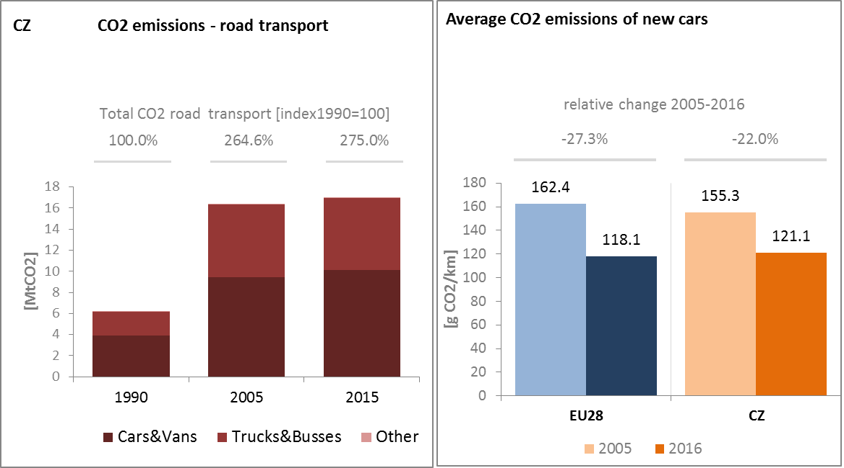

*(Source: European Environment Agency)*

**Alternative Fuels Infrastructure**

The share of electric cars in total sales on the Czech market was still marginal in 2015, but increased considerably as comparing to 2014. In 2015, 0.16 % of new cars sold in the Czech Republic have been hybrid-electric and electric cars.

Over the last four years the number of electric charging points in the Czech Republic has more than tripled, while the largest increase was observed between 2015 and 2016 when the number increased from 320 to 435 units.

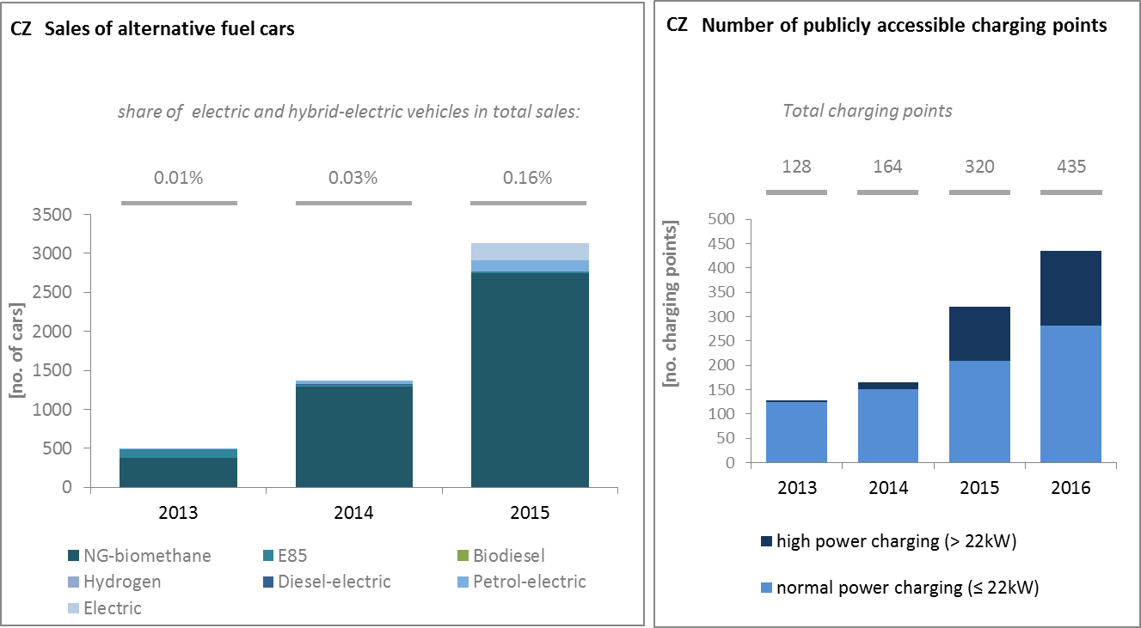

*(European Environment Agency) (European Alternative Fuels Observatory)*

National Policy Frameworks under Directive 2014/94/EU on alternative fuels infrastructure have to establish targets, objective and measures for the development of the market of alternative fuels in the transport sector and the deployment of the relevant infrastructure. The Czech Republic has submitted its National Policy Framework as requested under article 3 of the Directive 2014/94/EU.

A detailed assessment of the Czech National Policy Framework in terms of its compliance with the requirements of Directive 2014/94/EU on alternative fuels infrastructure, its contribution to achievement of long-term energy and climate objectives of the Union and coherence of its targets and objectives in terms of cross-border continuity has been published as part of the Communication on Alternative Fuels Action Plans (COM(2017)652) and  the related staff working document SWD(2017)365.

* 1. **Adaptation to climate change**

The Czech Republic adopted its Strategy on Adaptation to Climate Change (NAS) in 2015. The National Action Plan on Adaptation to Climate Change was developed on the basis of this Strategy and approved in 2017. The following priority sectors were included in the strategy: water management, agriculture, forest management, biodiversity and ecosystem services, urbanized landscape, health and hygiene, crisis situations, protection of the population and environment, tourism and recreation, and the transport, industry and energy sectors. The monitoring and reporting system is being developed. The default status of indicators, for monitoring the NAS, is defined and the whole monitoring system should be operational by the end of 2017.

**5.3. Taxes on energy and transport and fossil fuel subsidies**

The overall tax burden on energy and transport in the Czech Republic amounts to 2.1 % of GDP, which is 0.3 % below the EU average. The tax burden on transport fuel is higher than the EU average, while taxes on transport vehicles as well as heat and electricity are well below the EU average. Taxation of heat and electricity has shown an increase since 2005 while the tax burden on vehicles and transport fuels has in contrast fallen since 2005, leading to an overall decrease in energy an transport related taxes since 2005.

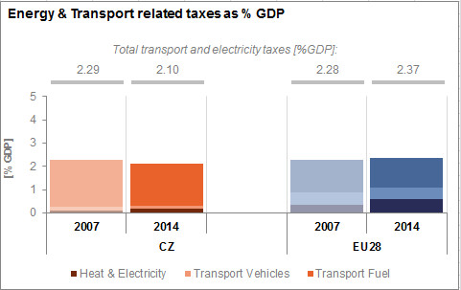

*(Source: Eurostat*

In the Czech Republic, fossil fuel subsidies have been relatively stable over the last decade, with however a sharp and dramatic increase in 2009: that year, about CZK 37 billion (EUR 1.5 billion) of public money were allocated to fund environmental clean-up projects on abandoned coal mines throughout the country.

For instance, a state aid of CZK 600 million (EUR 24 million) was granted to cover exceptional costs arising from the process of closing the uncompetitive Paskov mining unit and that are not related to coal production. In particular, the aid was intended to cover the expenditure on workers who have lost or who will lose their jobs at the coal production unit and to workers entitled to such payments before the closure[6]

**]

*(source: OECD Inventory of Support Measures for Fossil Fuels 2015)*

**5.4. Renewable energy**

The Czech Republic has already met its 2020 targets for renewable energy, primarily due to significant investments in the sector over the recent years, and to the high share of renewables in heating and cooling and electricity generation. Renewable energy accounted for 15.1 % of final energy consumption in 2015, being above the 2020 target of 13 %. Although the share of renewable energy continued to grow until 2014, changes to renewables support schemes in the energy sector have negatively impacted their potential, and in 2015 the Czech renewable energy development stagnated. The main changes were that feed-in tariffs or premium tariffs for new power plants were abolished by the end of 2013. Only renewable energy plants put into operation before 31 December 2013 receive the feed-in or premium tariff. For wind, hydro or biomass plants put into operation since 2014, they only benefit from support if the building permit was issued before 2 October 2013. Also since January 2011, PV plants over 30 kWp put into operation in 2010 are subject to the payment of a retroactive solar tax.

Renewable energy share was nearly 20% in 2015 in the heating and cooling sector and it was 14.1 % in electricity generation. The use of biofuels in transport decreased in 2015 to 6.5 % and it stayed below the specific target of 10 % renewable energy in transport.

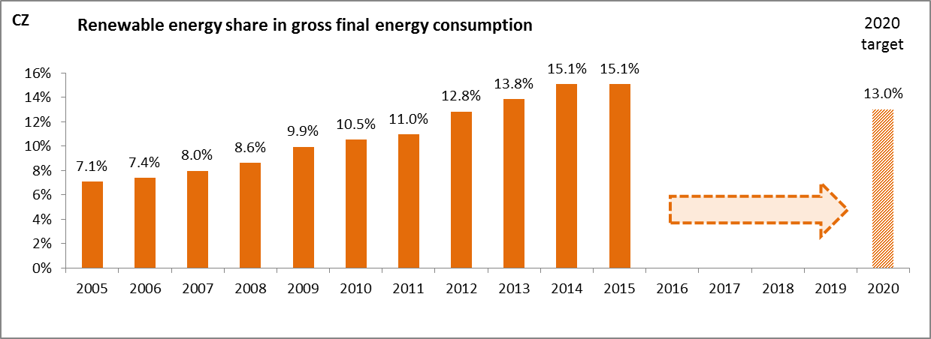

*(source: Eurostat-SHARES)*

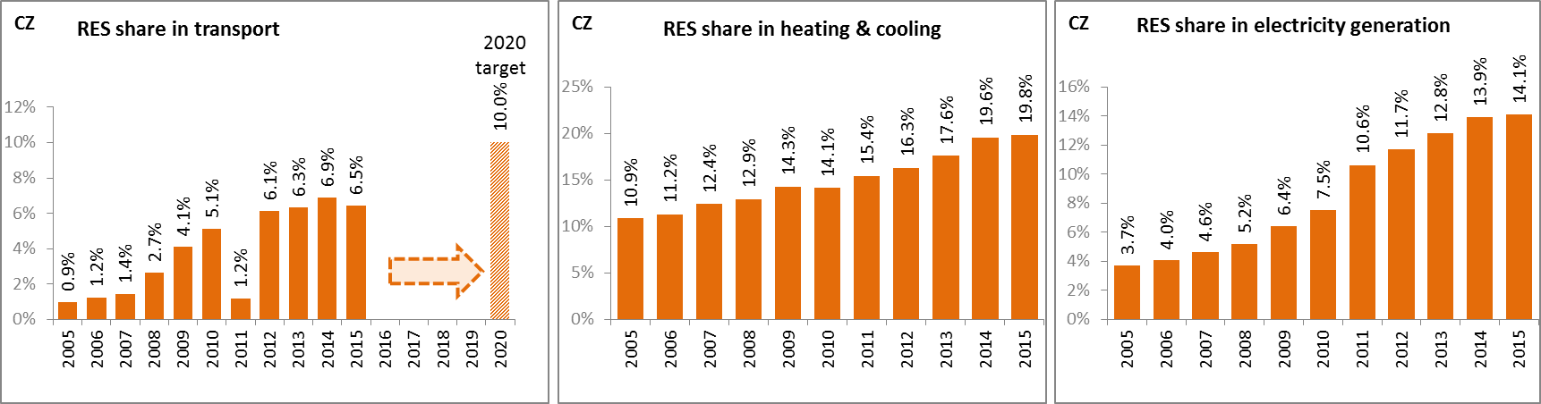

*(source: Eurostat-SHARES)*

Due to a consistent deployment of renewables since 2005, it is estimated that the Czech Republic avoided in 2015 about 9 % of the fossil fuel in gross inland consumption and about 8.2 % of GHG emissions at national level.

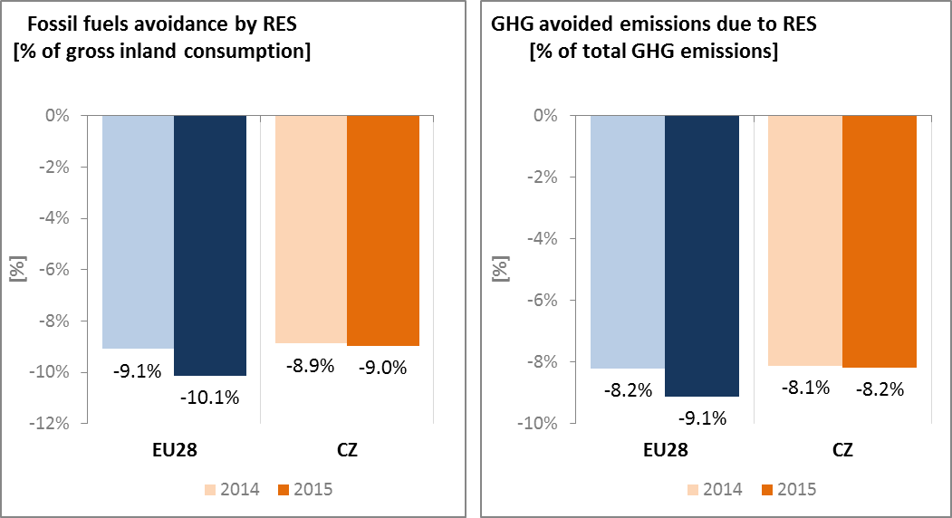

*(Source: EEA)*

**5.5. Contribution of the Energy Union to better air quality**

Air quality in the Czech Republic continues to give cause for concern. For the year 2013, the European Environment Agency estimated that about 12,030 premature deaths were attributable to fine particulate matter (PM2.5) concentrations and 330 to nitrogen dioxide (NO2) concentrations[7].

For both pollutants, the Czech Republic reported exceedances of the binding EU air quality standards[8]. For the year 2015, the Czech Republic reported exceedances of the limit value for PM10 in 5 out of the 10 air quality zones in the Czech Republic, while exceedances of the limit value for PM2.5 were reported in 3 out of the 10 zones, and exceedances of the NO2 limit value in 1 zone.

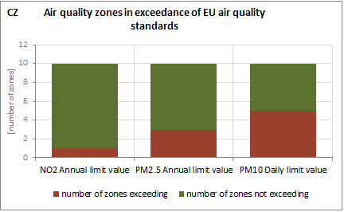

(Source: EEA)

The health-related external costs from air pollution in the Czech Republic have been estimated to be more than 6 billion€/year (income adjusted, 2010), which includes the intrinsic value of living a healthy life without premature death as well as the direct costs to the economy such as healthcare costs and lost working days due to sickness caused by air pollution[9].

The Energy Union can substantially contribute to addressing these air quality problems through measures reducing emissions of both GHG and air pollutants such as PM and nitrogen oxides (NOx) from major contributing sectors such as (road) transport, energy production, industry and residential heating (e.g. stoves and boilers) as shown in the figure below[10].

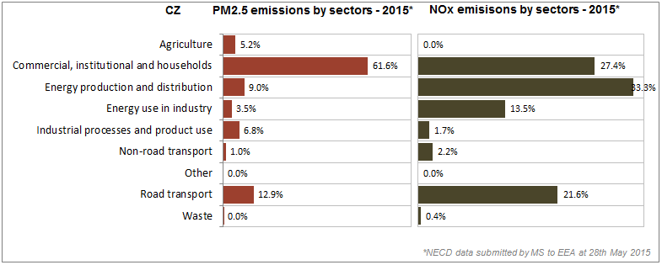

*(Source: EEA. This table reflects only sources of primary PM2,5 emissions.)*

1. **Research, innovation and competitiveness** 
   1. **Research and innovation policy**

Energy research in the Czech Republic is informed on one hand by the EU's policy of CO2 emission reductions and on the other by Czech energy policy developing a secure and independent energy supply for the country.

The current National Research, Development and Innovation Policy identifies eight main research priorities. The third priority focuses on energy sources, with an emphasis on nuclear fission; thermonuclear fusion; renewable and alternative energy sources (biomass, wind, geothermal and solar energy); energy systems and networks; and fossil fuels (combustion and multi-fuel operation). Other research areas, such as materials, the environment, security and defence issues, also have close links to energy.

A new comprehensive programme on R&D in energy was adopted in 2017, spanning over the period 2018-2025 with total funding from the national budget amounting to 150 million EUR (approx. 20 million EUR per year). The first call is expected to be launched in the second half of 2017.

The Czech Republic is not very active in the ongoing work of the Strategic Energy Technology (SET) Plan; it only participates in two (out of fourteen) temporary working groups for the implementation of the integrated SET Plan, the ones dedicated to nuclear safety and energy efficiency in buildings/renewable heating and cooling.

Regarding the Horizon 2020 programme, the Czech Republic has received so far 0.7 % of the EU contribution devoted to the 'secure, clean and efficient energy' part of the programme. As of September 2017, 63 participations from Czech organisations have been awarded EUR 13.1 million in Horizon 2020 energy projects. This includes four grants totalling over EUR 1.6 million to Czech beneficiaries participating in project InterFlex (demonstration projects on energy system flexibility), and a grant of over EUR 0.6 million to the University of Chemistry and Technology (Vysoka Skola Chemicko-Technologicka V Praze) for its participation in project BioMates (innovative biofuels).

* 1. **Investments and patents in the Energy Union R&I priorities**

Based on provisional reporting, in 2016, public (national) investments in the Energy Union R&I priorities reached EUR 18 million, which corresponds to about half of the public investment in 2015[11]. The Smart Systems and Nuclear Safety R&I priorities of the Energy Union attracted the largest share of investments, with 36 % and 35 % of the total respectively. In the period 2007-2016, the maximum public investment was EUR 44 million in 2012. In 2014, the most recent year for which data for most Member States are available, public investment per GDP was lower than the EU average.

Private investment in the Energy Union R&I priorities in 2013 was estimated at EUR 63 million (0.4 % of the private R&I investment in Energy Union R&I priorities in the EU). The focus was on Efficient Systems, which attracted 53 % of these investments, followed by Sustainable Transport with a share of 21 %.

In 2013, the most recent year for which complete patent[12] statistics are available, 33 companies and research organisations based in the Czech Republic filed 26 patents in low-carbon energy technologies (0.4 % of the EU total). The focus was on Efficient Systems (50 %), followed by Smart Systems (22 %) and Sustainable Transport (15 %).

In 2013, both private investments and patents in Energy Union R&I priorities were lower than the EU average when normalised by GDP and by population respectively. In the period 2007-2013, private R&I investments decreased by 9 % per year on average, contrary to the respective EU indicator that increased at an average rate of 6 %. For the same period, the number of patents increased by 3 % on average, a rate of increase being lower than the respective EU indicator (15 %).

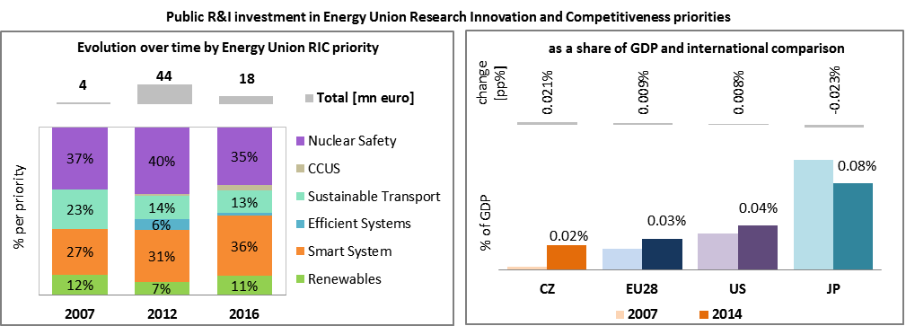

*Note: The international comparison (right) is shown for 2014 (Czech Republic had reported EUR 36 million). Reporting at EU level for 2015 is not as complete, and very few countries have reported for 2016.*

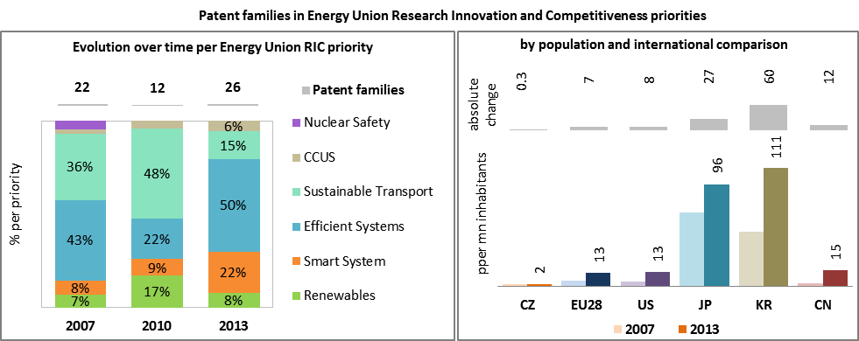

*(Data sources: Public investment as available in the International Energy Agency RD&D Statistics database[13] for codes relevant to Energy Union RIC priorities. Patent data based on the European Patent Office PATSTAT database[14]. Private investment as estimated by JRC SETIS. Detailed methodology available from the JRC[15].)*

* 1. **Competitiveness**

Since 2005 the real unit energy costs (RUEC)[16] in the Czech Republic were decreasing. In 2014 they were at 17.4 %, being above those at the EU average (15.3 %), more than twice of those in the US but below those in Japan, Russia and China. This can be partly explained by the specialisation of the Czech Republic in energy intensive industries. In the second half of 2016, electricity prices paid by industrial customers in the Czech Republic were below OECD and slightly below the EU averages. Gas prices for industrial consumers were slightly below the EU and were comparable to the OECD average.

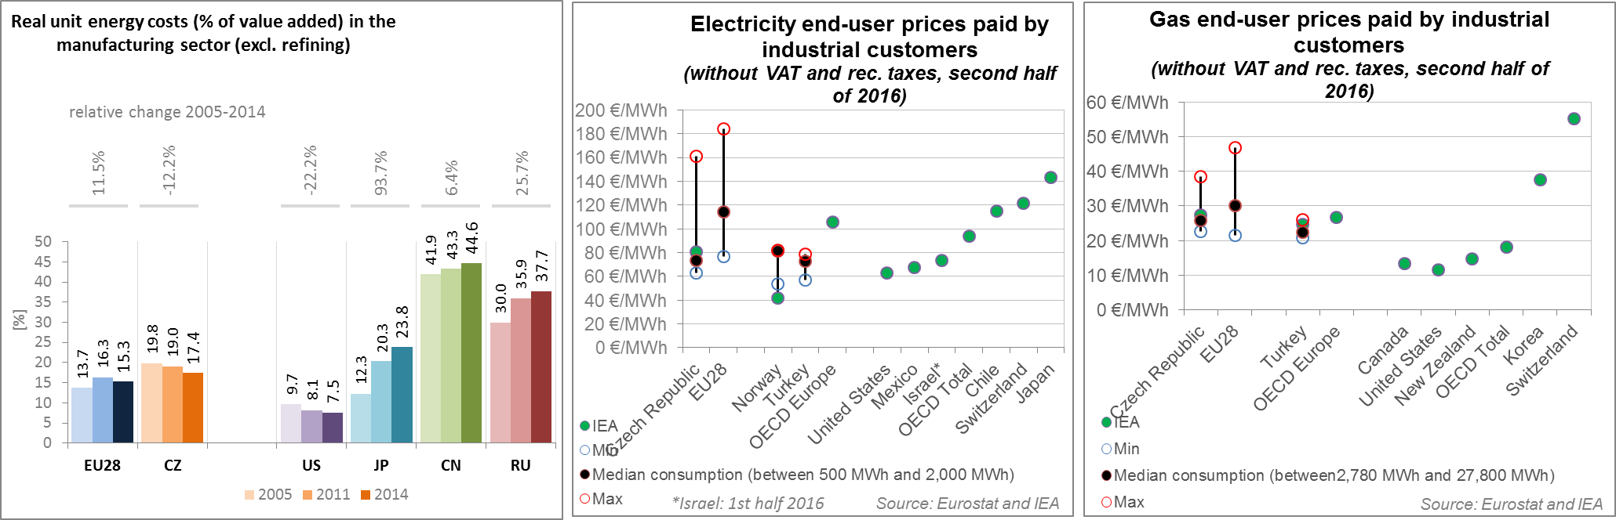

*(Source: ECFIN) (Source: ESTAT and IEA)*

Regarding the competitiveness in wind and solar energy, the Czech Republic has a comparative advantage in the solar sector as indicated by a value above 1 of the revealed comparative advantage (RCA) indicator[17]. This can be attributed to a comparative advantage in power electronics for solar photovoltaic panels. The Czech economy is not specialised in wind energy as indicated by the RCA indicator below 1 in 2015, a change compared to 2005 when the Czech Republic still had an RCA indicator above 1. This is mainly due to a loss in comparative advantage in key components of wind turbines such as generators and gearboxes .The Czech Republic expanded its comparative advantage in power electronics between 2005 and 2015 for both wind and solar photovoltaic technologies. Despite the comparative advantage in solar energy, the Czech Republic has a slightly negative relative trade balance[18] for solar energy components, whereas they are a net exporter of wind energy components, although below average EU levels.

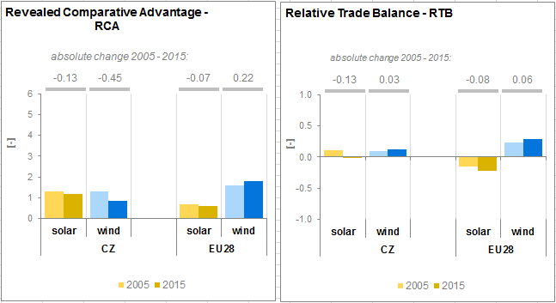

*(Source: UN Comtrade)*

1. **Regional and local cooperation**

The Czech Republic is part of the North-South, electricity interconnections in the following regional cooperation initiatives:

* Central Eastern and South Eastern Europe regional priority corridor for electricity,
* North-South gas interconnection in Central Eastern and South Easter Europe as well as South Gas Corridor regional priority corridors for gas,
* South South-East Gas Regional Initiative (GRI),
* Continental Europe ENTSO-E system operation regional group,
* TSC Regional Security Coordinator (RSC), and
* GRIP Central-Eastern Europe.

The EU macro-regional strategy for the Danube Region in which the Czech Republic takes part can be used as a basis for regional cooperation on energy. The Czech Republic is a co-coordinator of the priority area 'To encourage more sustainable energy'. European Territorial Cooperation – 'Interreg' – under EU cohesion policy also provides further opportunities for cross-border, transnational and interregional cooperation, including in the Energy Union areas.

Cities and urban areas have a key role in the energy and climate challenge. The Urban Agenda for the EU, established by the Pact of Amsterdam in May 2016, better involves cities in the design and implementation of policies, including those related to the Energy Union. It is implemented through partnerships, in which the Commission, Member States, cities and stakeholders work together on a number of important areas, including on Energy Transition, Urban Mobility, Air Quality, Climate Adaptation and Housing. The Czech Republic is participating in the partnerships on Urban Mobility, as the co-coordinator, and Air Quality, as a member.

By 2016 sustainable energy action plans delivered by 5 Czech municipalities had been assessed by the Covenant of Mayors. Overall, these municipalities cover 344 thousands inhabitants. All together, these municipalities committed to reduce by 2020 the GHG emissions by 24.7% (as compared to 1990 baseline).

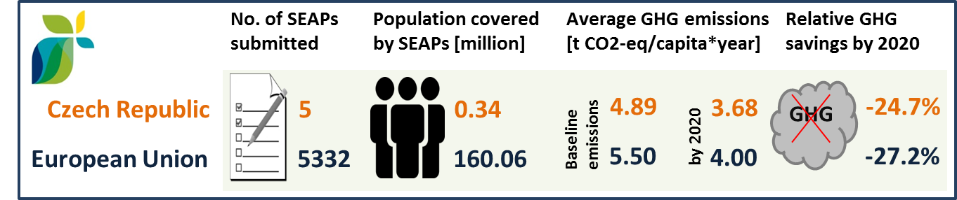

*(source: JRC 2016. Notes: SEAP=sustainable energy action plan, GHG=greenhouse gas emissions)*

In the Czech Republic, by September 2016, 3 cities (covering 1.38 million inhabitants) have committed to conduct vulnerability and risk assessment and develop and implement adaptation plans in the framework of the Covenant of Mayors for Climate and Energy.

1. **Cohesion policy and EU clean energy investments**

EU cohesion policy makes a key contribution to delivering the Energy Union objectives on the ground, including important investment possibilities to implement energy policy objectives in the Czech Republic, which are complemented by national public and private co-financing, aiming at optimal leverage. It also ensures integrated territorial solutions to energy and climate challenges, supports capacity building and provides technical assistance.

Over 2014-2020, cohesion policy is investing some EUR 2 508 million in energy efficiency improvements in public and residential buildings and in enterprises, as well as in high-efficiency cogeneration and district heating, renewable energy and smart energy infrastructure in the Czech Republic. Cohesion policy is also investing significant funds in R&I and in SME competitiveness in the Czech Republic, based on the national strategy for smart specialisation. For the Czech Republic, the strategy includes a focus on sustainable and safe production and distribution of electricity. At this stage, at least EUR 164 million is foreseen for investments in R&I and adoption of low-carbon technologies in the Czech Republic, but this might increase further in line with the evolving content of the smart specialisation strategy. A further estimated EUR 3,040 million is invested in supporting the move towards an energy-efficient, decarbonised transport sector.

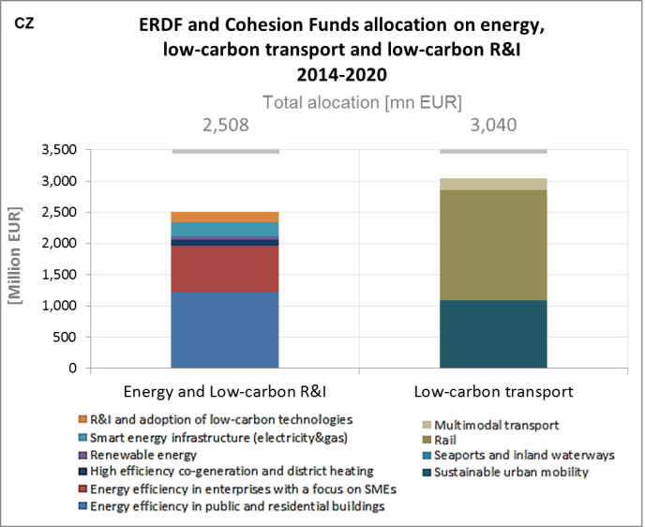

*(source: DG REGIO)*

These investments are expected to contribute to around 75,000 households with improved energy consumption classification, a decrease of around 26,862,000 kWh per year of primary energy consumption of public buildings, 100 MW of additional capacity of renewable energy production, as well as to around 100 km of reconstructed or upgraded railway lines and 8 km of new or improved tram and metro lines. Overall, the EU cohesion policy investments in the Czech Republic over 2014-2020 are expected to contribute to an estimated annual decrease of GHG emissions of around 1,105,000 tonnes of CO2eq.

For example, the project to increase energy efficiency of the elementary school building in Horní Benešov involved thermo-modernisation of the school, with the city of Benešov as beneficiary. The project objective was to reduce energy consumption used for heating by improving insulation of the civil structures and envelope of the building. The cohesion policy funding contribution amounted to EUR 54,000 EUR.

As another example, the project in the milk production facility in Jaroměřice aimed to reduce the energy intensity of the company's operation, mainly by realizing heat-saving measures. The company has a present daily production capacity of around 120 000 litres of milk. This company's production programme includes cheeses, cottage cheese, traditional spread butter and classic butter of high quality raw materials. The measures taken were mainly gas heat pump installations for combined heating and refrigeration. The cohesion policy funding contribution amounted to EUR 39 000.

Through its support to sustainable transport systems, the Connecting Europe Facility (CEF) also contributes to the goals of the Energy Union. Following the Czech participation in the CEF – Transport programme 2014-2015, the Czech action portfolio comprises 38 signed grant agreements, allocating EUR 842.4 million of actual CEF Transport Funding to Czech beneficiaries (state-of-play February 2017)[19]. The transport mode which receives the highest share of funding is rail (92.8 % of actual funding). The rail actions have three main objectives, of which the most important is to upgrade the rail infrastructure in order to eliminate the existing capacity and interoperability bottlenecks along the three Core Network Corridors crossing the country. The second targets the deployment of The European Railway Traffic Management System (ERTMS), while the third addresses interoperability and implementation of Rail Freight Corridors. In the road sector, the Czech Republic developed and modernised the motorway infrastructure, implemented Intelligent Transport Systems and Services (ITS), and made innovation aiming at greening the road transport.[20]

1. The indicators used in this country factsheet largely build on indicators developed for the Commission Staff Working Document "Monitoring progress towards the Energy Union objectives – key indicators" (SWD(2017) 32 final) <https://ec.europa.eu/commission/sites/beta-political/files/swd-energy-union-key-indicators_en.pdf>
2. Gross value added and employment in NACE sectors D-Electricity, gas, steam and air conditioning supply and H-Transportation and storage
3. National accounts, Eurostat
4. Gross fixed capital formation consists of resident producers´ acquisitions, less disposals, of fixed tangible or intangible assets. This covers, in particular, machinery and equipment, vehicles, dwellings and other buildings. It also includes foreign direct investment (FDI). Steam and air conditioning supply are also included in the figures mentioned above as Eurostat reports electricity, gas, steam and air conditioning supply together.
5. The interconnectivity level is calculated as a ratio between import interconnection and net generation capacities of the country (i.e. the 2017 value is the ratio between simultaneous import interconnection capacity [GW] and net generating capacity [GW] in the country at 11 January 2017, 19:00 pm as resulted from ENTSO-E Winter Outlook 2016/2017)
6. <http://ec.europa.eu/competition/state_aid/cases/254578/254578_1680719_130_2.pdf>
7. European Environment Agency, 2016, [Air Quality in Europe – 2016 Report](https://www.eea.europa.eu/publications/air-quality-in-europe-2016), table 10.2. The report also includes details as regards the underpinning methodology for calculating premature deaths.
8. Directive 2008/50/EC of the European Parliament and of the Council of 21 May 2008 on ambient air quality and cleaner air for Europe, OJ L 152, 11.6.2008, p.1-44
9. See also the EU Environmental Implementation Review Country Report for the Czech Republic, SWD(2017)37 final of 3.2.2017
10. National emission data as reported by the Member States to the EEA (available on the EEA's Eionet/Central Data Repository), <http://cdr.eionet.europa.eu/fi/eu/nec_revised>
11. The values reported for 2016 are provisional; the respective figure for 2015 was EUR 34 million, 6% lower than 2014. Additionally, data in the 2015/16 submission correspond to the application of an improved methodology by the MS.
12. In the context of this document, the term 'patent' refers to patent families, rather than applications, as a measure of innovative activity. Patent families include all documents relevant to a distinct invention (e.g. applications to multiple authorities), thus preventing multiple counting. A fraction of the family is allocated to each applicant and relevant technology.
13. <http://www.iea.org/statistics/RDDonlinedataservice/>
14. <https://www.epo.org/searching-for-patents/business/patstat.html#tab1>
15. <https://setis.ec.europa.eu/related-jrc-activities/jrc-setis-reports/monitoring-ri-low-carbon-energy-technologies>
16. This indicator measures the amount of money spent on energy sources needed to obtain one unit of value added.
17. The RCA index for product "i" is defined as follows: ${RCA}_{i}=\frac{\frac{X_{j,i}}{\sum_{i}{X_{j,i}}}}{\frac{X_{w,i}}{\sum_{i}{X_{w,i}}}}$ where $X$ is the value of exports, and j is the country and w is the reference group, the World economy. 2005 refers in the text to the indicator average over the 2000-2009 period, while 2015 represents the average over the 2010-2016 period. The same applies for the RTB indicator - see below.
18. The RTB indicator for product "i" is defined as follows: ${RTB}_{i}=\frac{X_{i}-M_{i}}{X_{i}+M_{i}}$ where $X_{i}$ is the value of product's "i" exports and $M_{i}$ imports.
19. Note that European Economic Interest Groups and International Organisations are excluded from the analysis.
20. Source: INEA